　　　　　　　　　　　　　　　闽科外函〔2023〕9号

福建省科学技术厅转发科技部国际合作司关于征集2023年度“中韩青年科学家

交流计划”中国青年科学家赴韩

工作交流项目的通知

各有关单位：

现将《科技部国际合作司关于征集2023年度“中韩青年科学家交流计划”中国青年科学家赴韩工作交流项目的通知》（国科外便〔2023〕12号）转发给你们，请有意向申报的单位根据科技部通知要求认真做好人员推荐和推荐材料准备工作,确保所提交材料真实有效；不得填报涉密或敏感内容。并于2023年2月28日前将单位推荐函及相关申报纸质材料一式二份(签字盖章齐全)报送至省对外科技交流中心，逾期将不予审核推荐。

省对外科技交流中心联系人：俞璇

联系电话：0591-87871764

省科技厅对外合作处联系人：杜文霞

联系电话：0591-87882339

附件：《科技部国际合作司关于征集2023年度“中韩青年科学家交流计划”中国青年科学家赴韩工作交流项目的通知》

福建省科学技术厅

2023年2月10日

（此件主动公开）

附件

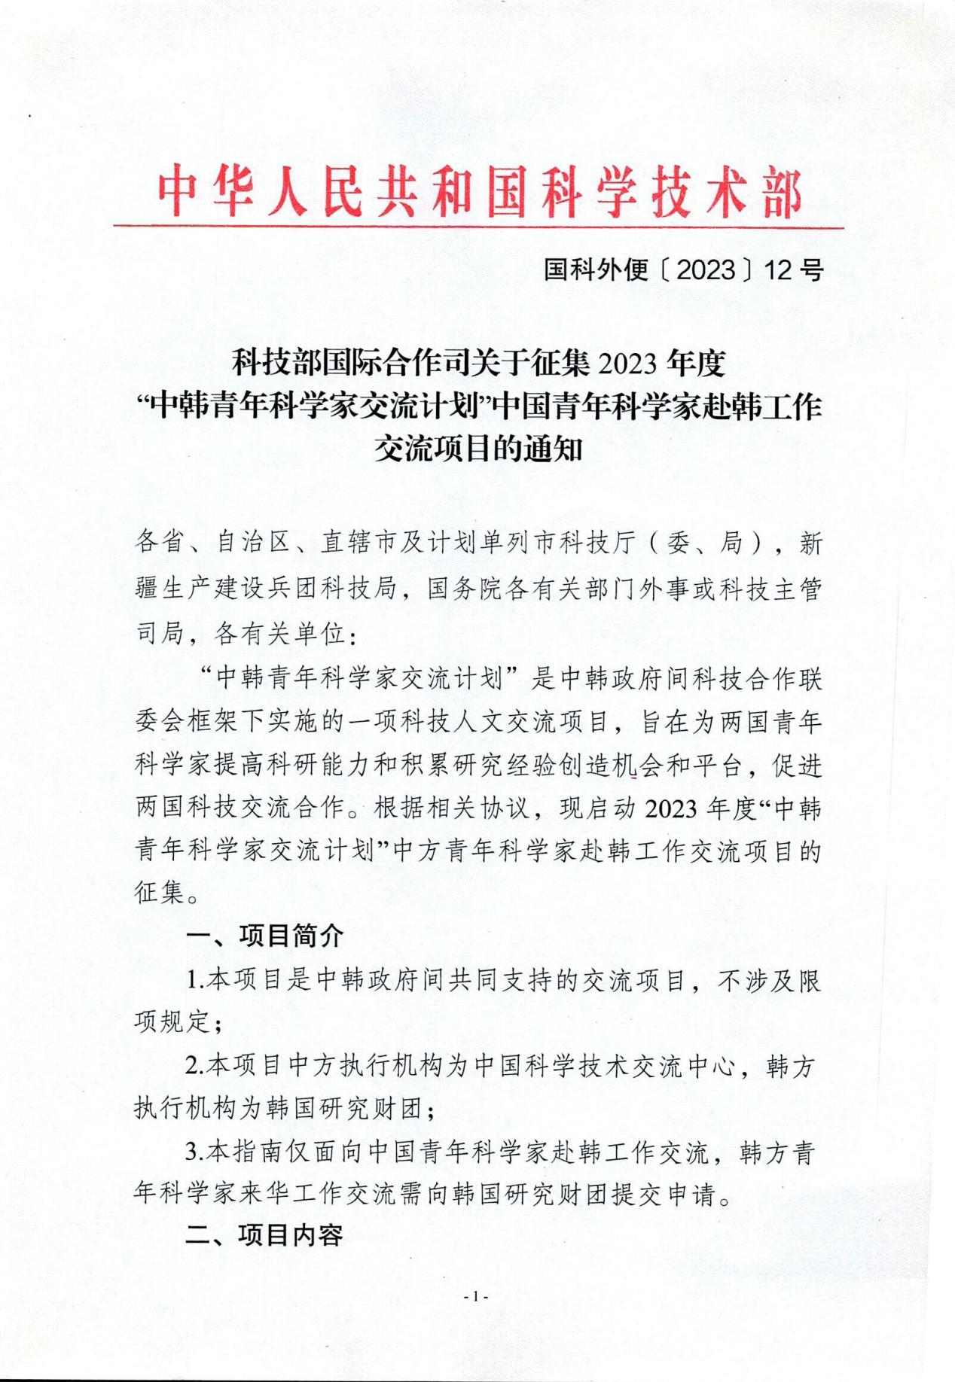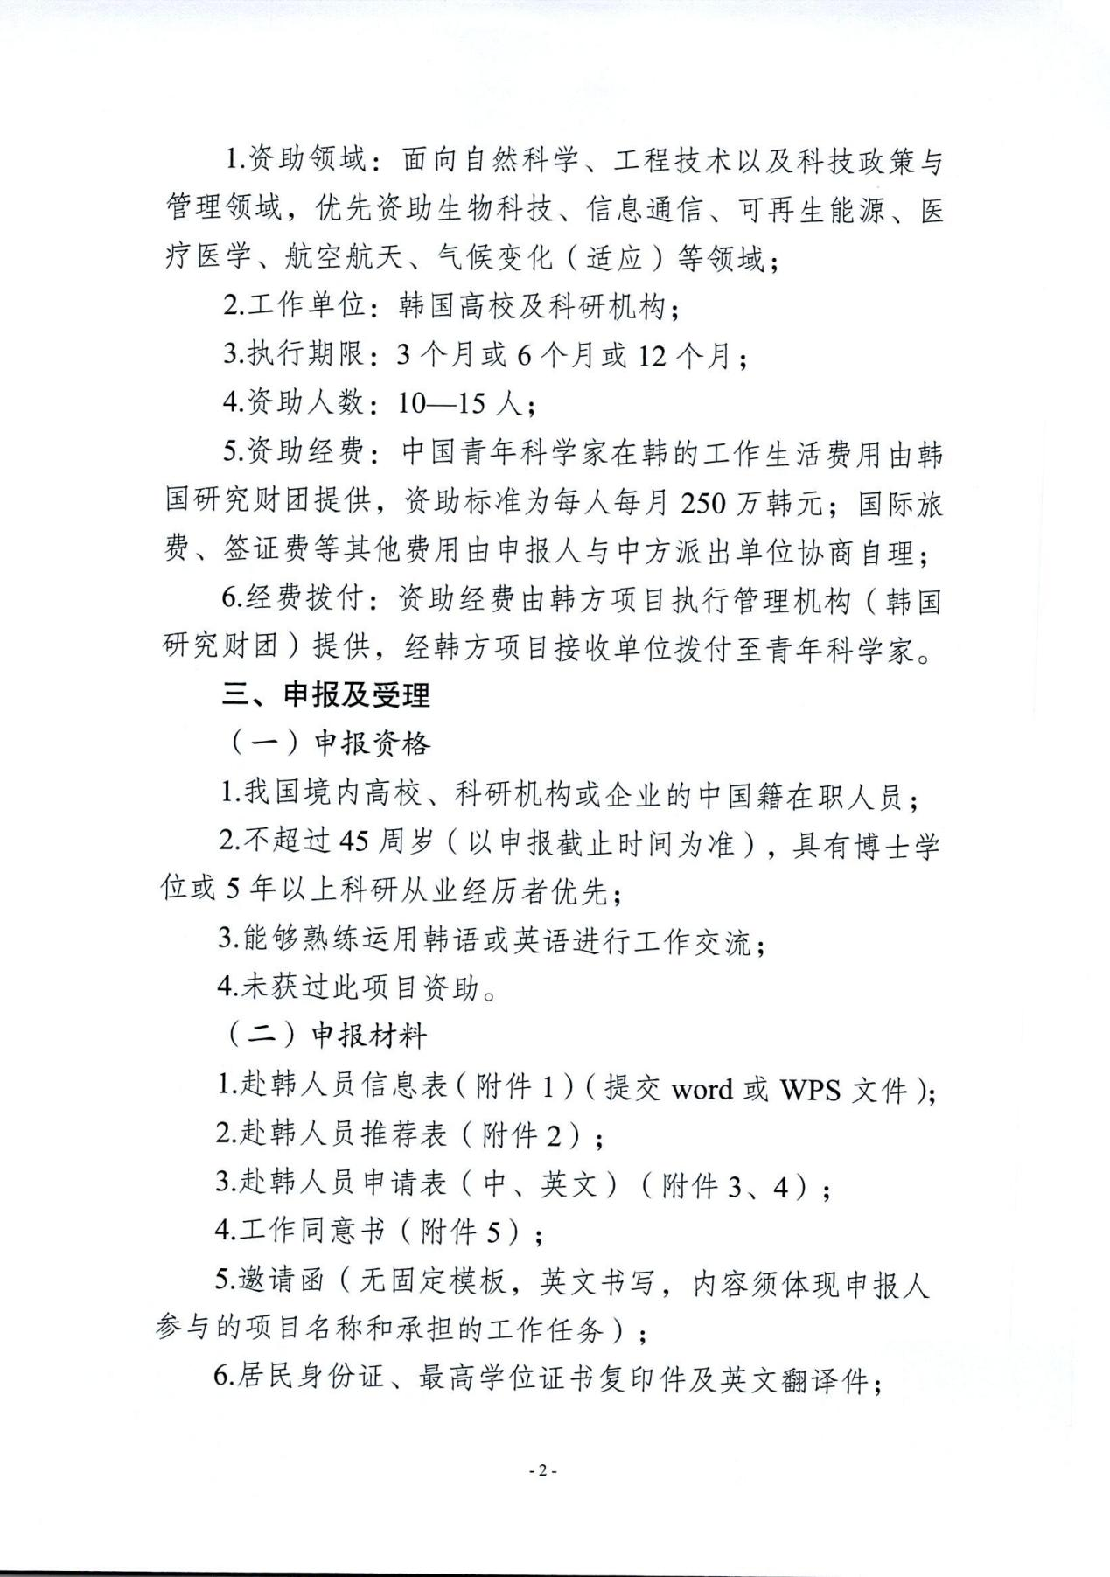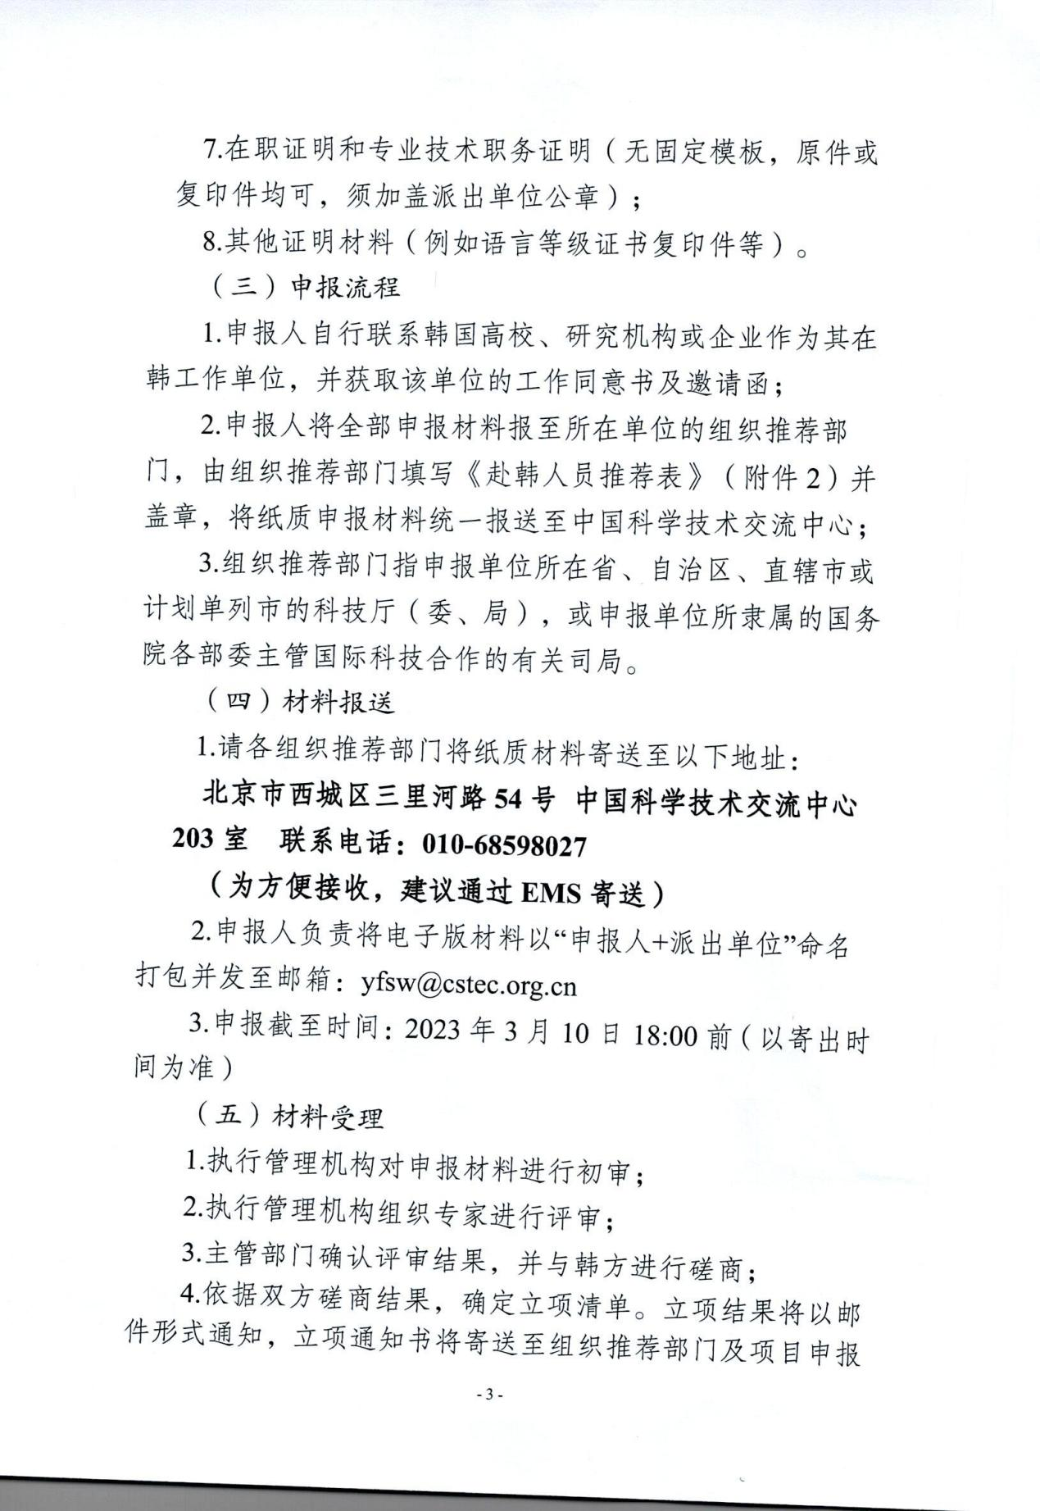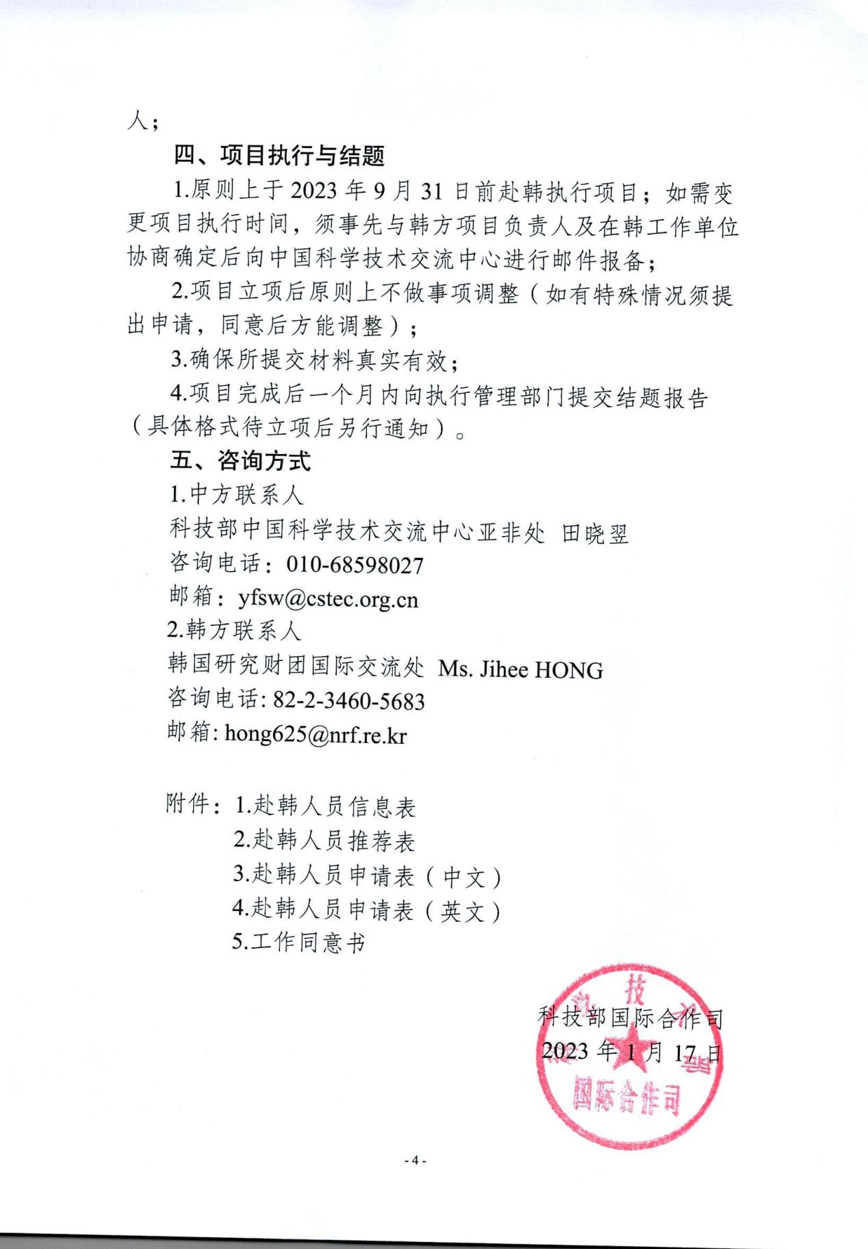

附件1

**2023年度“中韩青年科学家交流计划”赴韩人员信息表**

|  |  |  |  |  |  |  |  |  |  |  |  |  |  |  |  |  |  |  |  |  |  |  |  |  |  |  |  |  |  |  |
| --- | --- | --- | --- | --- | --- | --- | --- | --- | --- | --- | --- | --- | --- | --- | --- | --- | --- | --- | --- | --- | --- | --- | --- | --- | --- | --- | --- | --- | --- | --- |
| **个人信息** | | | | | | | | | **现工作单位** | | | | | **韩方接收单位** | | | **赴韩期限** | | **申报人联系方式** | | | | | **韩方接收单位联系方式** | | | | | | |
| 姓名 | 国籍 | | 生日  （年/月/日） | | | 性别 | | 专业 | 名称 | | | 职位 | | 名称 | | 工作岗位 | 手机 | | 座机 | 地址 | | 联系人 | | 手机 | 邮箱 | | 地址 | |
|  |  | |  | | |  | |  |  | | |  | |  | |  | 自 年 月至 年 月 | |  | |  |  | |  | |  |  | |  | |
| **Personal information** | | | | | **Current Unit** | | | | | **Receiving Unit** | | | **Length of stay in Korea** | | **Contacts of Applicant** | | | | | | | **Contacts of Receiving Unit** | | | | | | | | |
| Name | Nationality | DOB | Gender | Major | Name | | Position | | | Name | Position | | ____ months | | Mobile Number | Office Number | | Email | | Post Address | | Contact Person | Mobile Number | | Office Number | | | Email | | Post Address |
|  |  |  |  |  |  | |  | | |  |  | | From to | |  |  | |  | |  | |  |  | |  | | |  | |  |

**注：此表电子版请发送可编辑格式。**

附件2

**2023年度“中韩青年科学家交流计划”赴韩人员推荐表**

|  |  |  |  |  |  |
| --- | --- | --- | --- | --- | --- |
| **姓 名** | **性 别** | **出生年月** | **职 称** | **工作单位** | **韩方接收单位** |
|  |  |  |  |  |  |
| **外语水平（熟练程度如何，获得何证书）** | |  | | | |
| **对申请人学术水平、科研能力的评价意见：**  **（由申请人所在业务主管部门填写并加盖该部门公章）**      签名： 年 月 日 公章 | | | | | |
| **对申请人赴韩的意见：**  **（由派遣单位人事部门填写并加盖人事公章）**    签名： 年 月 日 公章 | | | | | |
| **对申请人赴韩的推荐意见：**  **（由组织推荐部门填写并加盖公章）**      签名： 年 月 日 公章 | | | | | |

**注：业务主管部门指申请人所在高校的院系、科研院所的科研处或企业相关业务部门；关于组织推荐部门的说明见征集指南“申报流程”。**

附件3

**2023年度“中韩青年科学家交流计划”赴韩人员申请表**

|  |  |  |  |  |  |  |  |  |  |  |
| --- | --- | --- | --- | --- | --- | --- | --- | --- | --- | --- |
| **姓名** | **国籍** | | | **出生日期** | | | **出生地** | | | 照片 |
|  |  | | |  | | |  | | |
| **工作单位** | **现任职务** | | | **联系电话** | | | **邮箱** | | |
|  |  | | |  | | |  | | |
| **韩方接收单位及项目负责人信息** | | | | | | | | | | |
| **接收单位名称** | **负责人姓名** | | | **负责人职务** | | | **所在院系** | | | **联系方式** |
|  |  | | |  | | |  | | |  |
| **赴韩时间** | 从: 年 / 月 / 日 至: 年 / 月 / 日 共 月 | | | | | | | | | |
| **家属是否同行** | 是[ ] 否[ ] | | | | | | | | | |
| **同行配偶** | 姓名及年龄 | | | | | | | | | |
| **同行子女** | 姓名及年龄 | | | | | | | | | |
| **是否正在同时申报或执行科技部其他项目，请说明项目名称：** | | | | | | | | | | |
| **教育背景（从大学起）** | | | | | | | | | | |
| 机构名称 | | 主要领域 | | | | 学术学位 | | | 起止日期 | |
|  | |  | | | |  | | |  | |
|  | |  | | | |  | | |  | |
|  | |  | | | |  | | |  | |
|  | |  | | | |  | | |  | |
| **外语能力** | | | | | | | | | | |
| 语言 | | 通过哪些语言考试 | | | | 获得相关语言证书 | | | | |
| 英语 | |  | | | |  | | | | |
| 韩语 | |  | | | |  | | | | |
| **主要学术成果介绍（包括著作、学术论文、专利等）** | | | | | | | | | | |
| **过去赴韩活动** | | | | | | | | | | |
| 起止日期 | | | 地点 | | 资助机构 | | | 赴韩访问目的 | | |
|  | | |  | |  | | |  | | |
|  | | |  | |  | | |  | | |
|  | | |  | |  | | |  | | |
| **过去及目前正在进行的相关研究介绍** | | | | | | | | | | |
| **在韩期间工作计划** | | | | | | | | | | |
| **日期: 本人签字:** | | | | | | | | | | |

附件4

**Application for Chinese Scientists**

# Young Scientist Exchange Program between

**The Republic of Korea and the People’s Republic of China**

Instruction: This form should be filled out in English.

|  |  |  |  |  |  |  |  |  |  |  |
| --- | --- | --- | --- | --- | --- | --- | --- | --- | --- | --- |
| **Name** | **Nationality** | | | **DOB** | | | **Birth of Place** | | | **Photo** |
|  |  | | |  | | |  | | |
| **Organization** | **Present post** | | | **Phone** | | | **E-mail** | | |
|  |  | | |  | | |  | | |
| **Korean receiver institution and Korean advisor** | | | | | | | | | | |
| **Institution** | **Name of advisor** | | | **Position** | | | **Department** | | | **E-mail** |
|  |  | | |  | | |  | | |  |
| **Length of Stay** | From: DD /MM/YY to: DD / MM / YY | | | | | | | | | |
| **Accompanying Family Members** | | | | | | | | | | |
| **Spouse** | Name and age | | | | | | | | | |
| **Children** | Name and age | | | | | | | | | |
| **The other projects which are being declared or executed simultaneously** | | | | | | | | | | |
| **Educational background (from university)** | | | | | | | | | | |
| Institution | | Major field | | | | Academic Degree | | | Year | |
|  | |  | | | |  | | |  | |
|  | |  | | | |  | | |  | |
|  | |  | | | |  | | |  | |
|  | |  | | | |  | | |  | |
| **Language proficiency** | | | | | | | | | | |
| Languages | | Language Test | | | | Language certificate | | | | |
| English | |  | | | |  | | | | |
| Korean | |  | | | |  | | | | |
| **Major academic works** | | | | | | | | | | |
|  | | | | | | | | | | |
| **Previous visits to Korea** | | | | | | | | | | |
| Year & length of study | | | Place | | Funding agency | | | Purpose of visits | | |
|  | | |  | |  | | |  | | |
|  | | |  | |  | | |  | | |
|  | | |  | |  | | |  | | |
| **Past and current research**  **(state past and current research relevant to the proposed research title)** | | | | | | | | | | |
|  | | | | | | | | | | |
| **Research plan under the fellowship program in Korea** | | | | | | | | | | |
|  | | | | | | | | | | |

附件5

**Letter of Consent**

|  |  |  |  |
| --- | --- | --- | --- |
| Organization |  | | |
| Contact person |  | Phone No. |  |
| Email address |  | | |
| This Letter is to affirm that  *organization name*  is willing to accept  *applicant name*  to work in the Korean organization mentioned above  during *MM/YY* to *MM/YY.*  The position will be  *position*  Signature:  Date:  Stamp： | | | |